RESOLUTION NO 001-2015

A RESOLUTION AUTHORIZING AND DIRECTING THE VILLAGE ADMINISTRATOR TO EXECUTE AN INDEPENDENT CONTRACTOR AGREEMENT WITH THOMAS COLEMAN FOR OPERATION AND MAINTENANCE OF THE VILLAGE’S WASTEWATER TREATMENT PLANT AND DECLARING AN EMERGENCY

WHEREAS, over the last year, the Village of Glenford has worked hard designing, planning, and constructing a complete sanitary sewer treatment facility that will consist of a traditional gravity collection system of 8” gravity mains and standard manholes to a centralized treatment plant; and

WHEREAS, Council for the Village of Glenford now needs to enter into an agreement with someone to operate and maintain the wastewater treatment plant and believes Thomas Coleman has the education, knowledge, and experience necessary to perform these services.

NOW, **THEREFORE, BE IT RESOLVED** by the Council of the Village of Glenford, County of Perry, State of Ohio:

Section 1: Council for the Village of Glenford hereby authorizes and directs the Village Administrator to execute an Independent Contractor Agreement with Thomas J. Coleman, in substantially the same form and content as the Agreement attached here as Exhibit A and incorporated herein by reference, for operation and maintenance of the Village’s wastewater treatment plant.

SECTION 2: All prior legislation, or any parts thereof, which is/are inconsistent with this Resolution is/are hereby repealed as to the inconsistent parts thereof.

SECTION 3: It is hereby found and determined that all formal actions of this Council concerning and relating to the adoption of this Resolution were adopted in an open meeting of this Council, and that any and all deliberations of this Council and any of its committees that resulted in such formal action were in meetings open to the public, in compliance with all legal requirements of the laws of the State of Ohio.

SECTION 4: Council declares this to be an emergency measure immediately necessary for the preservation of the public peace, health, and safety of this municipality and the further reason that the Village must enter into this agreement immediately so the Wastewater Treatment Plant Operator can begin working as soon as possible. Wherefore, provided this Resolution receives the required affirmative votes of Council, this Resolution shall take effect and be in force immediately upon passage by Council.

Passed in Council this _______ day of __________ 2015

____________________________

Leonard Sheppard, Mayor

ATTEST:

Linda Nicodemus, Fiscal Officer

APPROVED:

Approved as to form this 31st day of March 2015.

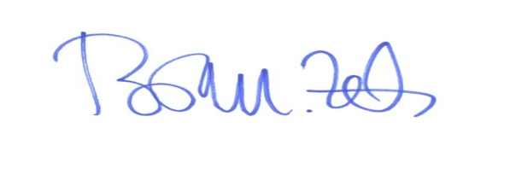

_________________________

Brian M. Zets, Esq.

Village Solicitor