ORDINANCE NO: 16-001
ADOPTED: _________________

AN ORDINANCE AUTHORIZING THE MAYOR AND FISCAL OFFICER TO EXECUTE A PERSONAL SERVICE AGREEMENT FOR LEGAL SERCVICES WITH ISAAC WILES BURKHOLDER & TEETOR, LLC, AND DECLARING AN EMERGENCY

WHEREAS, in January 2014, the Village of Glenford retained the law firm of Isaac Wiles Burkholder & Teetor, LLC, and in particular, attorney Brian M. Zets, to serve as its Village Solicitor; and

WHEREAS, the personal services contract for legal services expired January 1, 2016; and

WHEREAS, Council for the Village of Glenford understands and recognizes its need to retain an individual and law firm with a peculiar skill and aptitude to serve as Village Solicitor; and

WHEREAS, Council for the Village of Glenford is pleased with the level of service and work being performed currently by its Village Solicitor, and wants to continue this professional relationship; and

WHEREAS, Council for the Village of Glenford now wants to retain again the services of Isaac Wiles Burkholder & Teetor, LLC, and in particular, attorney Brian M. Zets, to serve as Village Solicitor.

NOW, THEREFORE, BE IT ORDAINED BY THE COUNCIL OF THE VILLAGE OF GLENFORD, PERRY COUNTY, OHIO THAT:

Section 1: The Mayor and Fiscal Officer are hereby authorized and directed to enter into an Agreement for Legal Services, in substantially the same format and content, as the document attached hereto as Exhibit “A” and incorporated herein by reference, on behalf of the Village of Glenford.

Section 2: It is hereby found and determined that all formal actions of this Council concerning and relating to the passage of this Ordinance were adopted in an open meeting of Council and that all deliberations of Council and any of the decision making bodies of the Village of Glenford which resulted in such formal actions were in meetings open to the public in compliance with all legal requirements of the State of Ohio.

Section 3: All prior legislation, or any parts thereof, which is/are inconsistent with this Ordinance is/are hereby repealed as to the inconsistent parts thereof.

SECTION 4: Council declares this to be an emergency measure immediately necessary for the preservation of the public peace, health, and safety of this municipality and the further reason that Village Council needs to approve and enter into this Agreement as soon as possible in order to continue providing the Village with uninterrupted legal services. Wherefore, provided this Ordinance receives the required affirmative votes of Council, this Ordinance shall take effect and be in force immediately upon passage by Council and approval by the Mayor.

Passed in Council this ___ day of February 2016
__________________________________
Leonard Sheppard, Mayor
ATTEST: ___________________________
Linda Nicodemus, Fiscal Officer

APPROVED:

Approved as to form this 1st day of February 2016:
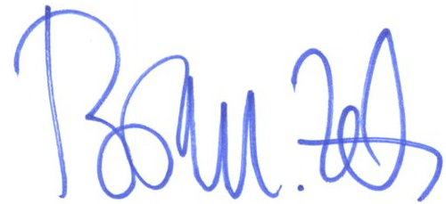
_________________________
Brian M. Zets
Village Solicitor

