RESOLUTION NO 013-2016

AUTHORIZING LEGISLATION

A RESOLUTION AUTHORIZING THE VILLAGE OF GLENFORD TO PREPARE AND SUBMIT AN APPLICATION TO PARTICIPATE IN THE OHIO PUBLIC WORKS COMMISSION STATE CAPITAL IMPROVEMENT AND / OR LOAL TRANSPORTATION IMPROVEMENT PROGRAM(S) AND TO EXECUTE CONTRACTS AS REQUIRED AND DECLARING AN EMERGENCY.

WHEREAS, the State Capital Improvement Program and the Local Transportation Improvement Program both provide financial assistance to political subdivisions for capital improvements to public infrastructure, and

WHEREAS, the VILLAGE OF GLENFORD is planning to make capital improvements to STREET PAVING, and

WHEREAS, the infrastructure improvement herein above described is considered to be a priority need for the community and is a qualified project under the OPWC programs,

NOW THEREFORE, BE IT RESOLVED by COUNCIL OF THE VILLAGE OF GLENFORD:

Section 1: The Administrator is hereby authorized to apply to the OPWC for funds as described above.

Section 2: The Administrator is authorized to enter into any agreements as may be necessary and appropriate for obtaining this financial assistance.

Section 3: Council declares this to be an emergency measure immediately necessary for the preservation of the public peace, health, and safety of this municipality and the further reason that the OPWC application is due on September 2, 2016 this Resolution shall take effect and be in force immediately upon passage by Council.

Approved by:

Passed in Council this _______ day of __________ 2016.

____________________________

Leonard Sheppard, Mayor

ATTEST:

Linda Nicodemus, Fiscal Officer

APPROVED:

Approved as to form this 23rd day of August 2016
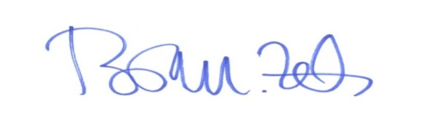
_________________________
Brian M. Zets, Esq., Village Solicitor

